Year 3 Spring Term Overview 2026
Welcome to Year 3 - Spring Term
As we move into the Spring Term, Year 3 will continue to build confidence, independence and enthusiasm for learning. Children will be challenged to deepen their skills across the curriculum, while continuing to develop resilience, curiosity and teamwork. This term is packed with exciting learning opportunities that support both academic progress and personal growth.
 | English  In English, children will continue to develop their reading and writing skills through daily whole class reading and structured English lessons. Our whole class reading text this term is ‘The Legend of Kevin’ by Philip Reeve, a humorous and engaging story that encourages prediction, inference and discussion.  Across the term, the children will explore a range of writing genres, including:  -Persuasive flyers, learning how to use persuasive language and layout to influence the reader  -“Tricking the monster” stories, focusing on plot development and character motivation  -Poetry using similes, encouraging creative language choices and imagery  -Triumphing stories, where characters overcome challenges using determination and problem-solving  Throughout all units, there will be a strong focus on expanding vocabulary, improving sentence structure, and applying grammar, punctuation and spelling accurately.
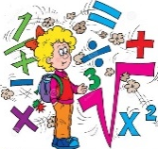 | Maths  In maths, children will move on to learning formal written methods of addition and subtraction, developing accuracy and confidence when working with larger numbers. Alongside this, children will continue to practise mental strategies and problem-solving skills.  Daily times tables practice remains a key focus, helping children to improve recall speed and mathematical fluency. These skills will support later work in multiplication, division and reasoning.
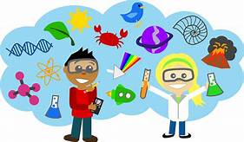 | Science  Science learning will begin with Forces and Magnets, where children will investigate how forces act, explore magnetic materials, and discover how magnets attract and repel.  Later in the term, the focus will shift to Plants. Children will learn about the different parts of a plant, their functions, and what plants need in order to grow healthy and strong. Observations and simple experiments will help develop scientific enquiry skills.
 | Geography  In geography, children will further develop their mapping skills, with a focus on Italy. They will learn how to use maps, atlases and globes to locate countries, cities and key physical features, making links to previous learning and improving their geographical vocabulary.
 | History  We will be recapping our history learning, to ensure the children can accurately recall the major facts.
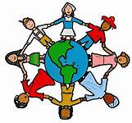 | Physical, Social, Health and Economic Education (PSHE)  We will continue working through the SCARF programme, which supports children’s personal development and emotional well-being. Key themes include:  Emotional awareness and resilience  Healthy lifestyles  Building positive relationships  Keeping safe  Lessons are age-appropriate and encourage discussion, reflection and respectful communication.
 | Art  This term’s art focus asks the question: “Can art tell a story?”  Children will study the work of Jacob Lawrence, exploring how artists use colour, shape and composition to convey meaning and narrative. They will create their own expressive artwork inspired by his style.
 | Design and Technology  In Design and Technology, children will explore food technology by designing and making a Victoria sponge cake. They will learn about ingredients, measuring, following a recipe, and evaluating their finished product.
 | Computing  Computing lessons will introduce children to coding using Scratch. Children will learn how to create simple programs using sequences and commands, developing problem-solving skills and logical thinking.
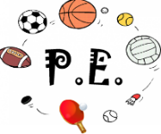 | Physical Education (PE)  In PE, children will work on developing gymnastic routines, focusing on balance, control, strength and sequencing movements. They will learn how to link actions smoothly and evaluate their own performances.
 | Music  This term’s musical theme is “Bring Us Together”, which celebrates the unifying power of music. Children will listen to and perform pieces that explore rhythm, melody and teamwork, reinforcing a sense of collaboration and enjoyment.
 | Religious Education (RE)  In RE, children will focus on Christianity and explore two key questions:  Could Jesus really heal people? Were these miracles, or could there be other explanations?  What is “good” about Good Friday?  Children will reflect on belief, symbolism and meaning through discussion and enquiry.
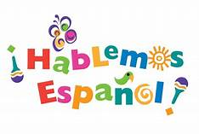 | Spanish  In Spanish, children will begin to build a foundation of vocabulary through stories, songs, drama and games. Learning a new language supports listening skills, confidence and cultural awareness, and children are always encouraged to join in and have fun.
Homework
Please remember to read with your child every day and sign your child’s reading record. Ensure that your child has their reading book in school every day.
Practise on Times Table Rockstars and practise spellings which are sent home.
As you can see Year 3 are going to be learning so many interesting things while developing their skills at the same time. We aim to provide a safe and happy environment in which your child will thrive and learn. We are looking forward to working with you and your child this year.
If you have any questions or problems, please come and speak to either Mr Joyce (Aspen) or Miss Neale (Cedar)

We look forward to seeing you at the Parent Consultations later in the term to discuss how your child has settled and their progress.

Thank you for your continued support.

Mr Joyce (Aspen) and Miss Neale (Cedar).

