Birch and Willow Class Year 5 Homework Autumn 1

We will be looking at the Geography of Greece and persuasive writing before moving on to narrative texts. In Science, we are learning about forces and in Maths we will start with place value - up to 6-digit numbers, then moving onto addition and subtraction.

Please remember to always present your homework neatly. Neatly presented homework will be rewarded with house points.
Photographs of work can be sent to the class teacher through Class Dojo.

English
1. As we will be looking at persuasive writing this half term, can you write a letter to persuade Mr Calderwood to give Year 5 longer break times in school? Remember to give good reasons and evidence to support your request!
2. Create a character and setting and remember to describe them using as much detail as you can. Can you now use them to create an interesting story?
3. Create a grammar poster showing these terms: noun, verb, adverb, pronoun, determiner and adjective. What do they mean? Give examples of each one in a sentence. Can you make a word bank to help you remember them for your writing?
Maths
1. If my answer is 852, what could the question be?
Can you write five more problems like this?

e.g. What is 700 + 152? or What is half of 1704?

2. Target 500

+

Each player has a grid (as above)
They each turn over a digit card or roll a dice and write the digit in one of the squares. This is repeated six times.
Once all the squares have been filled work out the total. The winner is the player closest to 500.

3. Play with a partner and take turns rolling the dice until you have made a 5-digit number.
You must decide where to put each digit depending on what your criteria are (e.g. biggest/smallest number, nearest to 50,000 nearest to 10,000 etc)

What number am I?
1. I am a three-digit number.
2. I am an odd number.
3. I am divisible by 5.
4. Each of my digits is different.
5. My digits add up to 8.
6. The tens digit is smaller than the hundreds digit.
7. I am less than 300.
8. I have only one even digit.
Can you make up some of your own using the above type questions
Wider Curriculum
Science – See below for the parachute investigation into air resistance. Don’t forget to record your results and label any diagrams.
Art - Sketch some of the famous Greek landmarks (both manmade and natural) such as the Parthenon Temple, Athens’ Acropolis and Mount Olympus.
Geography – Research the islands of Greece. How many are there? Which are inhabited? Which ones have the largest population? Can you find out any facts about them?

Continuous Provision
These are some facts that you should know from previous years. Try to learn as many of them as you can! You can find facts from other year groups on the school website, including those you need to know by the end of Year 5.

Geography - Using the map below, can you name countries in Europe and their capital cities?
History – When did the Roman Empire start and end? Which year did they invade Britain successfully? Can you also remember any important dates from the Viking history?
Science – Create a poster to show your understanding of ‘States of Matter’ – solids, liquids and gases.

Remember to read the newsletter each week to find out what is happening in school. You will earn a green card if you can correctly use the words in your own writing at school!

Alongside this, we encourage parents to do the following each week:
- Listen to your child read as often as possible and record this in their reading diary. Read to your child, this helps them with fluency. They will earn a house point each time an adult signs their diary.
- Regularly use Spelling Shed https://www.spellingshed.com/en-gb/ and https://www.spag.com/ to support your child’s spelling and grammar.
- Regularly use TTRockstars https://play.ttrockstars.com/
- They should know all of their times tables now so practise any that they are less confident with.

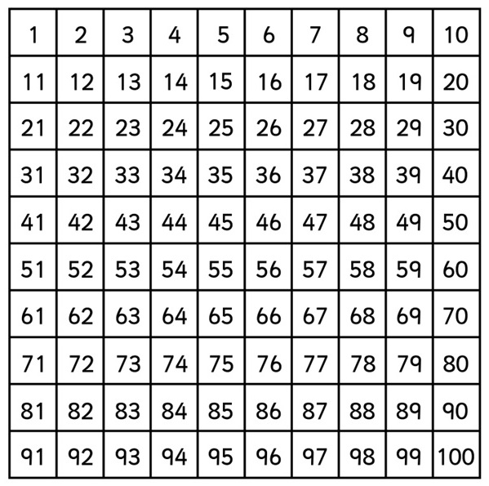

Year 3 and 4 Spelling List
accident  accidentally  actual  actually  address  answer  appear  arrive  believe  bicycle  breath  breathe  build  busy  business  calendar  caught  centre | century  certain  circle  complete  consider  continue  decide  describe  different  difficult  disappear  early  earth  eight  eighth  enough  exercise  experience | experiment  extreme  famous  favourite  February  forwards  fruit  grammar  group  guard  guide  heard  heart  height  history  imagine  increase  important | interest  island  knowledge  learn  length  library  material  medicine  mention  minute  natural  naughty  notice  occasion  occasionally  often  opposite  ordinary | particular  peculiar  perhaps  popular  position  possess  possession  possible  potatoes  pressure  probably  promise  purpose  quarter  question  recent  regular  reign | remember  sentence  separate  special  straight  strange  strength  suppose  surprise  therefore  though  although  thought  through  various  weight  woman  women

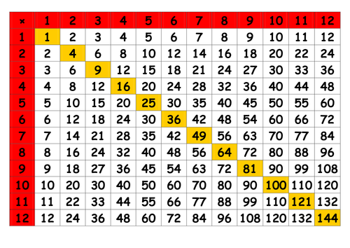

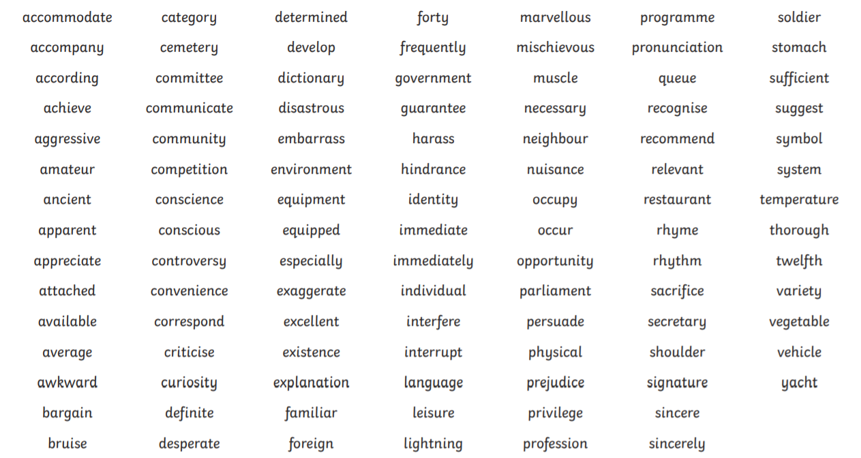
Year 5 and 6 Spelling List

