Weekly Maths Tasks | Weekly Reading Tasks
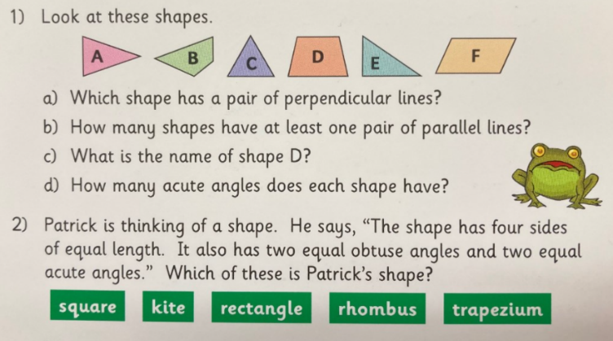  - Try these shape activities. Can you make up your own questions like these to solve?  - We will again be setting activities on Mathletics and encourage you to use TTRockstars to help you become more confident with your times tables. Remember you can also practise speed writing the multiples for the times tables you need to work on. (e.g. 6, 12, 18, 24, 30, 36…)  - Using a dice, create your own multiplication problems to solve (two/three digit multiplied by one digit). Check with a calculator. | Each day you should read for pleasure for at least 20 minutes (that maybe a chapter a day, depending on your book)  - Use books and the internet to research a winter holiday celebration. (Kwanzaa, Diwali, Thanksgiving, Hanukkah, Christmas). Produce a poster showing what you’ve learnt.  - Use research from the previous activity to create a comparison chart/Venn diagram showing the similarities and difference between the two.  - Read a holiday story as a family – to your parents, siblings or maybe grandparents.  - Read the Winter Wonderland poem attached. Answer the questions that follow.  - Using the Winter Wonderland poem write your own questions for someone else to answer. Can you write three retrieval questions, three vocabulary questions and a summary?
Weekly Spelling Tasks | Weekly Writing Tasks
- Practise spelling the Year 3 and 4 Common Exception words as well as review any Year 2 words you don’t know – use different methods to see what works best for you. e.g Look, Cover, Write.  imagine  increase  important  interest  island  knowledge  learn  length  library  material  - Use spellingframe.com and focus on list 30. Complete the practice activities and then the test.  - At the end the week, ask an adult or a sibling to test you on the words. Correct any spellings you got wrong  - Use spellingshed.com to practice throughout the week. | - Pick a holiday and write acrostic poem using it. (Kwanzaa, Diwali, Thanksgiving, Hanukkah, Christmas). For an extra challenge, can you make your poem rhyme?  - Write a thank you letter to a key worker you know who has worked really hard this year. Remember to say why you are proud of them and what you are going to do to say thank you. Perhaps you could cook them dinner, buy them flowers or make them a gift.  - Write a recipe for a holiday dish. It could be a meal, snack or a dessert. Perhaps one that your family has used for generations.  - Write a holiday story about whatever you want. Get creative! Remember to use all the techniques we have learnt in class.
Learning Project (To be done over the week)
History
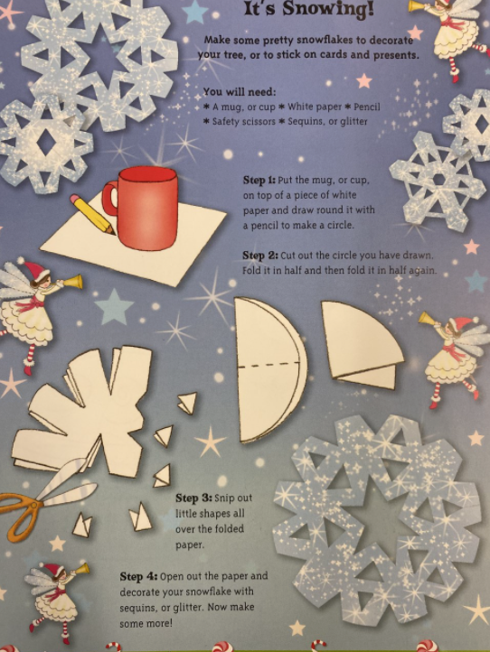
How was Christmas celebrated when your parents/grandparents were children? Is there anything they used to do that doesn’t happen anymore? Why do you think things have changed over the years?
If your family don’t celebrate Christmas – choose another festival to research.

Art/DT
Create snowflakes using these instructions. Use them to decorate your house! Send your photos to ravel.clark@downs.essex.sch.uk or daniel.joyce@downs.essex.sch.uk

Music
Ask your family members what their favourite Christmas songs are? Make a bar chart of your family’s favourite festive songs. You could even ring other members of your family who don’t live with you to find out!

Geography
Do you know how Christmas is celebrated in other countries? Find out how Christmas is celebrated in another country. Make a comparison chart / Venn diagram to show what is similar and different? Which one would you prefer?

Speaking and Listening
Play a game that doesn’t need a plug or batteries with your family.

Remember to read every day and we would love to see some of your lovely work.

