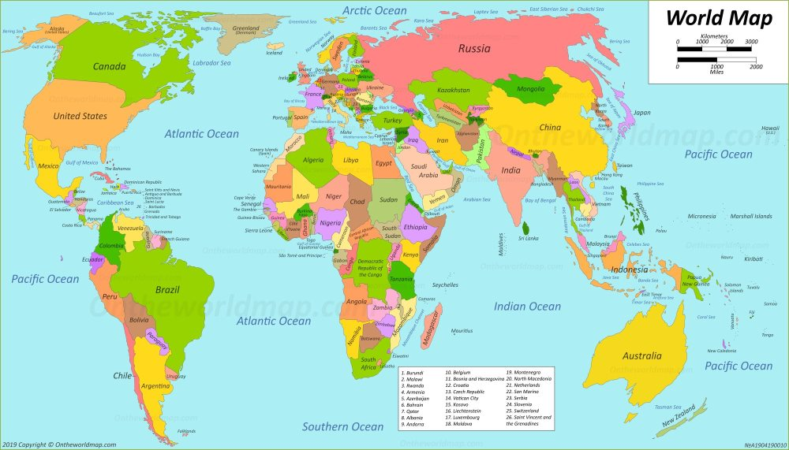
Geography – Continuous Provision

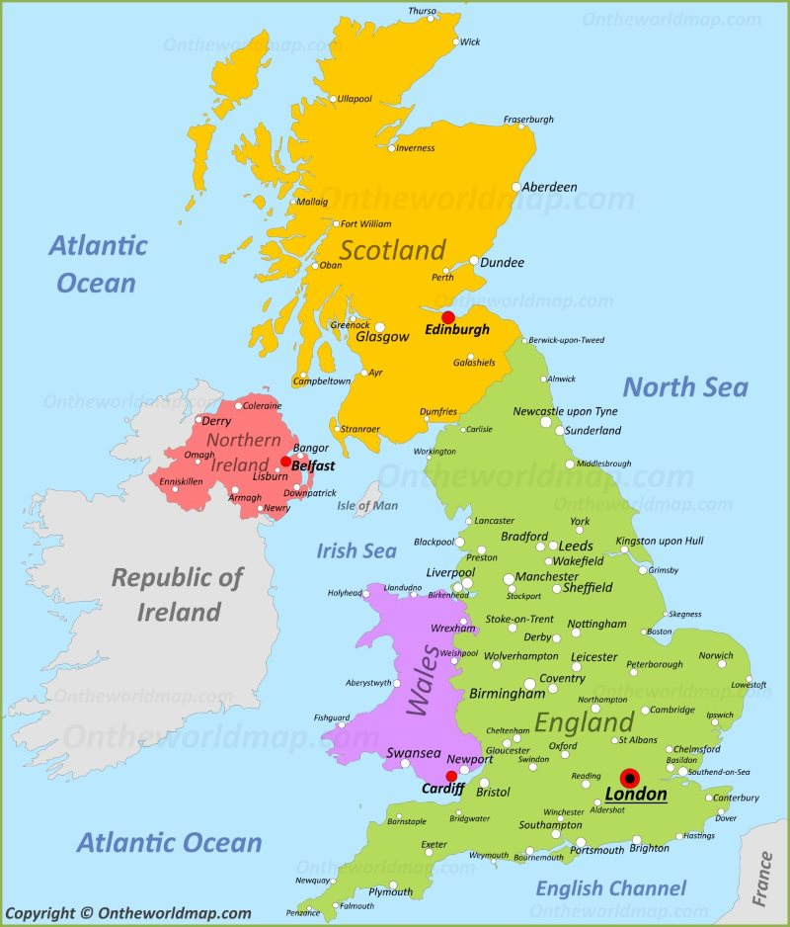
Year 1 | Year 2 | Year 3 | Year 4 | Year 5 | Year 6
Locate the 5 oceans on a world map.  Locate the UK on a world map  WEATHER:  Describe seasonal weather changes (Autumn, Winter, Spring, Summer)  Record daily weather for Harlow | Revise previous knowledge and skills  Name and locate the world’s seven continents  Identify the North and South poles  Name, locate and identify the characteristics of the four countries and capital cities of the United Kingdom.  WEATHER:  Describe seasonal weather changes (Autumn, Winter, Spring, Summer)  Record daily weather for Harlow  Identify seasonal and daily weather patterns in the United Kingdom. | Revise previous knowledge and skills  Name and locate cities of the UK (Chelmsford, Colchester, London, Birmingham, Manchester, Glasgow, Bristol, Liverpool, Portsmouth, Plymouth, Norwich, Canterbury)  WEATHER:  Explore and explain weather patterns/ conditions around the UK – link to weather patterns in Europe; can also be linked to current affairs (extreme weather happening in the news)  Record temperature and rainfall regularly -using the internet (compare to Rome, Italy) | Revise previous knowledge and skills  Recognise the different shapes of the continents  Identify where countries are within Europe and their capital cities  WEATHER:  Explore weather patterns around parts of the world – link to weather patterns in Europe; can also be linked to current affairs (extreme weathers happening in the news)  Record temperature and rainfall regularly - using the internet (compare to Stavanger, Norway) | Revise previous knowledge and skills  Identify seas, major rivers and mountains around the UK  Identify and describe the significance of the Prime/Greenwich Meridian and time zones  WEATHER:  Record wind direction and speed daily using the internet. (Harlow and Athens, Greece) | Revise previous knowledge and skills  Identify the position and significance of latitude, longitude, Equator, Northern Hemisphere, Southern Hemisphere, the Tropics of Cancer and Capricorn, Arctic and Antarctic Circle, the Prime/Greenwich Meridian and time zones (including day and night)  WEATHER:  Revise previous knowledge and skills (particularly the water cycle)  Daily record wind direction and speed using the internet. (Harlow and Buenos Aires, Argentina)

